Intake Form – STAGE 1
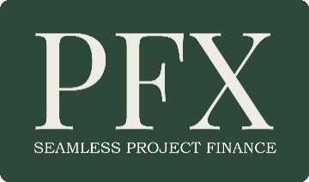
PFX is handling scores of projects at any one time. This form saves you, us, our investors, underwriters and others involved in your transaction a great deal of time. When we have reviewed this form and your executive summary, we will be in touch within three working days.

PLEASE LEAVE IN .DOC FORMAT. DO NOT CONVERT TO .PDF.
Introduction
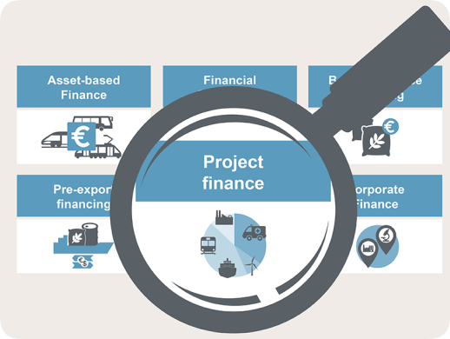
It is not generally appreciated that the Project Finance structure is unlike any other (M&A, Mezz, VC etc) in that funding is not dependent on your assets or balance sheet, but on the track record and financial stability of whoever is going to buy the output from your built project. This could be the grid your Power Purchase Agreement (PPA) is with, or the Management and Operating Agreement (MOA) for your hospitality, healthcare, infrastructure or other project.
Please complete and return this Stage 1 Intake Form with your Executive Summary (NOT the full deck at this stage) to the e-mail shown below. Next steps are:
- We will reply within three working days to arrange a call to discuss your project.
- All being well, we send you our Stage 2 Intake Form for you to complete. This asks for a lot more information and is designed to assure us that your project is submission ready, or as near as it can be to it. Please Note: Only the investor can decide when it is ‘shovel ready’. It also provides assistance in setting up and organising your data-room.
- We also prepare and send you our engagement agreement (there are no fees), our NCNDA and also our AML (anti-money laundering) statement and screening form. This is now required by most of our investors.
- Using our Listings Worksheet, we assist in preparing your PFX listing. Once listed on PFX investors know that your project is ‘submission ready’ to their acceptable intake standards. No identifying information is available on the elevator pitch which is shown on the PFX ‘Pipeline’ page. Only PFX registered investors can view your Exec Summary and other confidential information.
- Our Investor Liaison team will identify the investor most suited to your project and will contact you directly once we have confirmed interest from an investor.
- You engage directly with the investor.
Before moving forward please ensure:
- All your permits, permissions and other statutory documentation are complete, valid, bought and paid for. Investors cannot assist with any pre-financing costs.
- If land is involved in your project it will need to be owned, optioned, leased or controlled by you in some other way.
- You will need an off-take, power purchase or other agreement with a credible entity who is going to buy the output from your built project at least in advanced draft form.
- If an agreement as described in (3) above is not available, a feasibility study from an independent and credible source will be required.
- Your EPC (engineering, procurement and construction) contract will need to be with a company that can show track record and financial stability in the project’s specific market sector.
- If you are building a renewable energy plant, hospital or other project that needs specialist contractors your contracts with them will need to be available either directly or through your EPC.

PLEASE READ THE PROJECT FINANCE DEFINITION OF BELOW
Project Finance is defined as investment predicated on the track record and financial stability of whoever is contracted to buy the output from the built project and not those of the project principals or their company or government agency. These same track record and financial stability criteria apply to all the project’s contractors and other counterparties.
In cases where no contracted buyer can be shown but a feasibility study clearly demonstrates the viability of the project (in that there is absolute/underwrite-able assurance that any loan will be repaid) it needs to be credible and backed with sound and qualified research. Also, a project can qualify if the applicants can show a track record of success in operating the built project. This usually applies to hospitality, energy and similar sectors where specialist operating knowledge is required.

On all questions below please insert ‘x’ between [ and ] – ie: [x] -where appropriate

Does your project meet the ‘project finance’ criteria as defined above? Yes [ ] No [ ]

If you answered ‘No’ we regret your opportunity does not qualify for listing on PFX.

If ‘Yes’ please complete the following Intake Form (use N/A where appropriate):

PROFESSIONAL ADVISORS
If you are a professional advisor, such as business/corporate finance consultant, accountant, lawyer etc with clients who occasionally need project finance raising support, you can use our Direct Intake Service (DIS). Please visit the ‘Prof Advisors’ zone at the site for further information.

PROJECT PRINCIPALS: Please continue to complete and submit this form.

This Stage 1 Q&A provides basic information for our intake analysts.
Question: | Answers):
Name of company
Legal status (i.e. Limited, S.A., Inc.)
Applicant’s main contact
Position in company
Country of registration
Company/tax or other registration number
Company main address
Telephone
Email
Website
What is the project total cost (USD, GBP or EUR)?
Where is the project located (country, state/province)
How much capital are you looking to raise?
How much have you already invested?
Can you show documentation to prove expenditure so far?

- What market sector(s) is your project in (‘x’ all that apply)?
Agri [ ]; Airports [ ]; Aviation [ ]; Bio-Fuels [ ]; Bridges [ ]; Care Homes [ ]; Clinics/Hospitals [ ]; Commercial RE [ ]; Dams [ ]; Fisheries/Fish Farming [ ]; Healthcare []: Hotels/Resorts [ ]; Hospitality []; Hydro-Electricity [ ]; Infrastructure [ ]; In-Ground Assets [ ]; Leisure/Recreation [ ]; Media [ ]; Nuclear Energy [ ]; Oil & Gas [ ]; Ports [ ]; Potable Water [ ]; Power Distribution [ ]; Renewable Energy [ ]; Residential RE [ ]; Road/Rail [ ]; Satellites (Commercial) [ ];
Senior Living [ ]; Shipping/Marine [ ]; Social Infrastructure [ ]; Social/Affordable Housing [ ]; Solar Farms [ ]; Spaceports [ ]; Technology, Media & Telecommunications (TMT) [ ]; Trams [ ]; Transport/Distribution/Warehousing [ ]; Tunnels [ ]; Utility (gas, water, sewage etc) [ ]; Waste Recycling [ ]; Waste-to-Energy [ ]; Waste-to-Fuel [ ]; Wave/Tidal Energy [ ]; Windfarms [ ];

- Please describe your project in no more than 100 words:

Once completed please return this form with ONLY your Executive Summary (do not send your entire full deck) to:

SUBMISSIONS@PROJECTFINANCEEXCHANGE.COM

Your submission will be reviewed and we will contact you to arrange a meeting. Following that meeting you will be asked to complete our Stage 2 (Pre-Listing) form which asks for a lot more information regarding availability of documentation covering permits, permissions, contracts and agreements with your engineering, procurement and construction (EPC) contractors and other counterparties to your project. We will also require confirmation of availability of off-take, management and operating, power purchase and similar agreements. All this documentation will need to be made available in your data-room for your investor.

You can also find further information on how to prepare your project finance application in The Raising Project Finance Handbook, which is now the official PFX User Guide. It costs little more than a visit to your coffee shop, but has helped hundreds of project principals prepare their submissions since first published in 2020. Just click the cover image below to view more on Amazon.

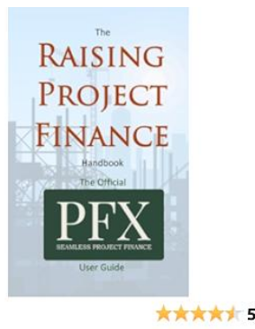

© Copyright and Intellectual Property Rights Notice
The copyright and Intellectual property rights to this PFX Intake Form are the property of Exchange Media (PFX) Ltd registered in England No 13617543 and is for use only by principals preparing to list projects on the Project Finance Exchange (PFX). It may be used by intermediaries only when preparing submissions to PFX on behalf of clients and not for use with their own clients.

